Computer Organization & Assembly Language

BS (CS) _Fall_2024

Lab_3 Manual



Name: Muhammad Moiz Ansari
Roll No: 23i-0523

Tasks:

Q1
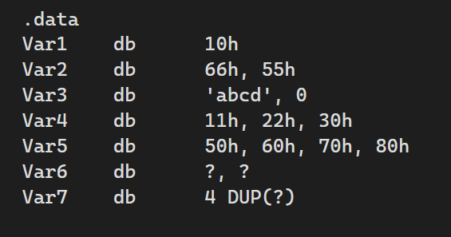
Fill the memory after execution and also write which format the it is saved in your computer(little endian or big endian). It is stored in Little Endian
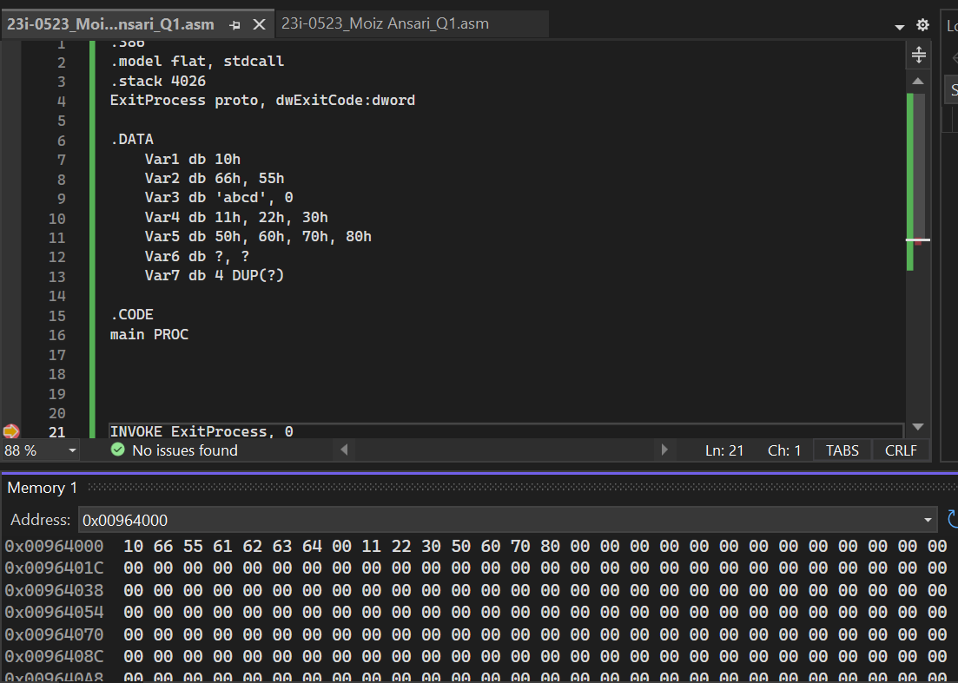
 | 01 | 02 | 03 | 04 | 05 | 06 | 07 | 08 | 09 | 0A | 0B | 0C | 0D | 0E | 0F
0000 | 10 | 66 | 55 | 61 | 62 | 63 | 64 | 00 | 11 | 22 | 30 | 50 | 60 | 70 | 80
0010 | 00 | 00 | 00 | 00 | 00 | 00 | 00 | 00 | 00 | 00 | 00 | 00 | 00 | 00 | 00
0020 | 00 | 00 | 00 | 00 | 00 | 00 | 00 | 00 | 00 | 00 | 00 | 00 | 00 | 00 | 00
Q2
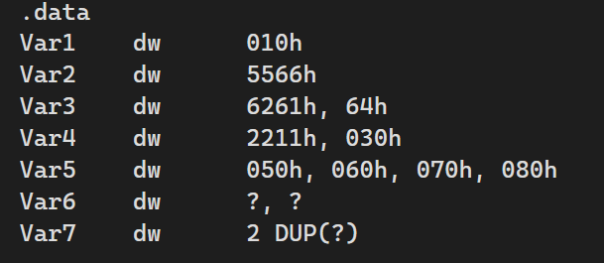
Fill the memory after execution and also write which format the it is saved in your computer(little endian or big endian). Little Endian
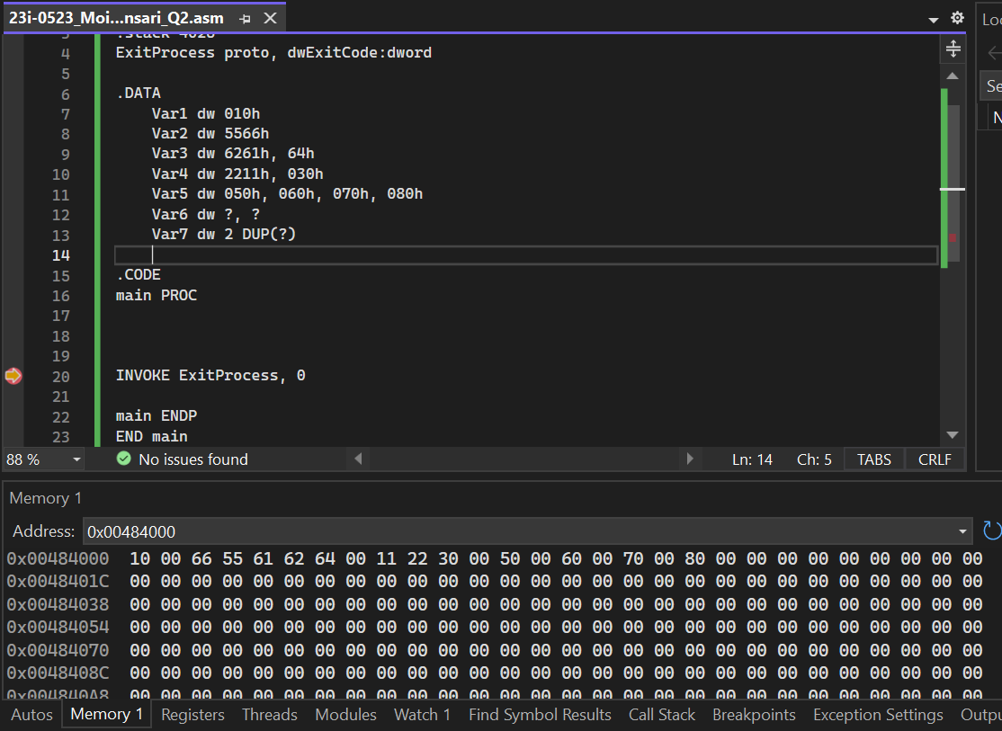
 | 01 | 02 | 03 | 04 | 05 | 06 | 07 | 08 | 09 | 0A | 0B | 0C | 0D | 0E | 0F
0000 | 10 | 00 | 66 | 55 | 61 | 62 | 64 | 00 | 11 | 22 | 30 | 00 | 50 | 00 | 60
0010 | 00 | 70 | 00 | 80 | 00 | 00 | 00 | 00 | 00 | 00 | 00 | 00 | 00 | 00 | 00
0020 | 00 | 00 | 00 | 00 | 00 | 00 | 00 | 00 | 00 | 00 | 00 | 00 | 00 | 00 | 00
Q3:
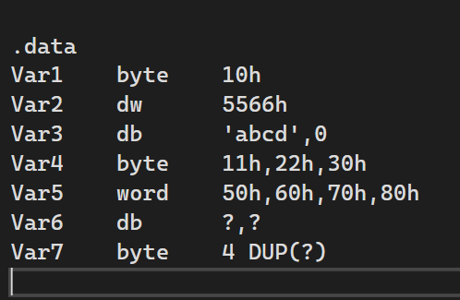

Fill the memory in term of big endian format.
 | 01 | 02 | 03 | 04 | 05 | 06 | 07 | 08 | 09 | 0A | 0B | 0C | 0D | 0E | 0F
0000 | 10 | 55 | 66 | 61 | 62 | 63 | 64 | 00 | 11 | 22 | 30 | 00 | 50 | 00 | 60
0010 | 00 | 70 | 00 | 80 | 00 | 00 | 00 | 00 | 00 | 00 | 00 | 00 | 00 | 00 | 00
0020 | 00 | 00 | 00 | 00 | 00 | 00 | 00 | 00 | 00 | 00 | 00 | 00 | 00 | 00 | 00

Q4: Declare and Initialize Arrays of Various Data Types
- Objective: Create arrays of different data types and initialize them with non-zero values.
- Steps:
  - Declare and initialize a byte array with values, e.g., byteArray db 1, 2, 3, 4, 5.
  - Declare and initialize a word array with values, e.g., wordArray dw 10, 20, 30, 40.
  - Declare and initialize a double word array with values, e.g., dwordArray dd 100, 200, 300.
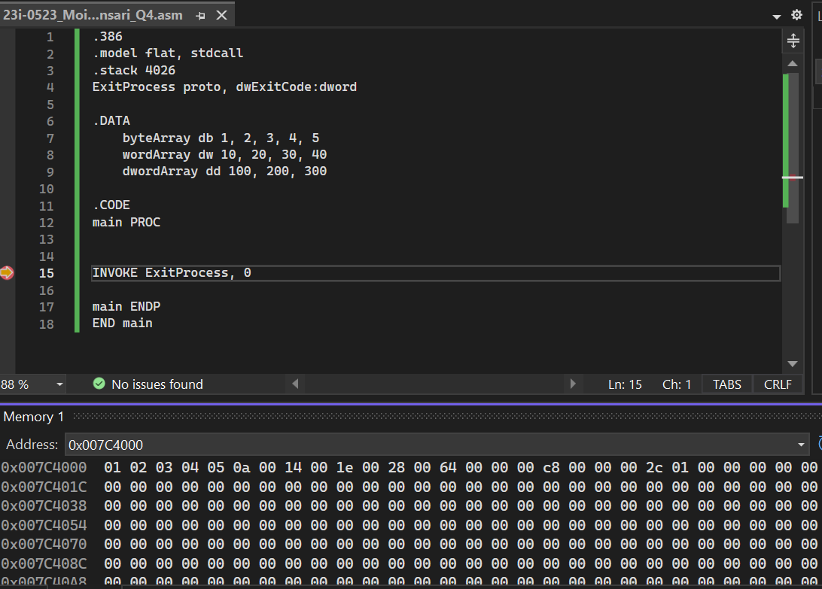
Q5: Verify Little Endian Memory Storage
- Objective: Confirm that your system uses little-endian format by storing and inspecting a multi-byte value.
- Steps:
  - Declare and initialize a 32-bit variable with a specific value, e.g., 0x12345678.
  - Store this value in memory.
  - Verify that the value is stored in little-endian format (i.e., 78 56 34 12).
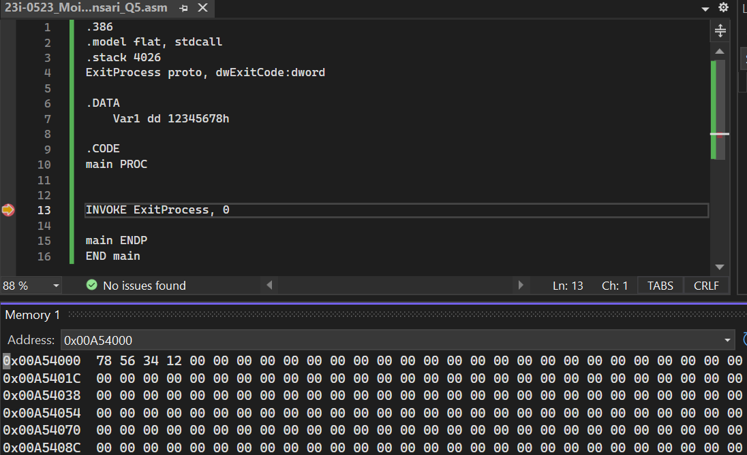
Q6: Determine and Save Array Type
- Objective: Identify the type of an array and store this information in a variable.
- Steps:
  - Define a variable to hold the array type description, e.g., arrayType db "byte".
  - For each array type (byteArray, wordArray, dwordArray), store the corresponding type in the variable.
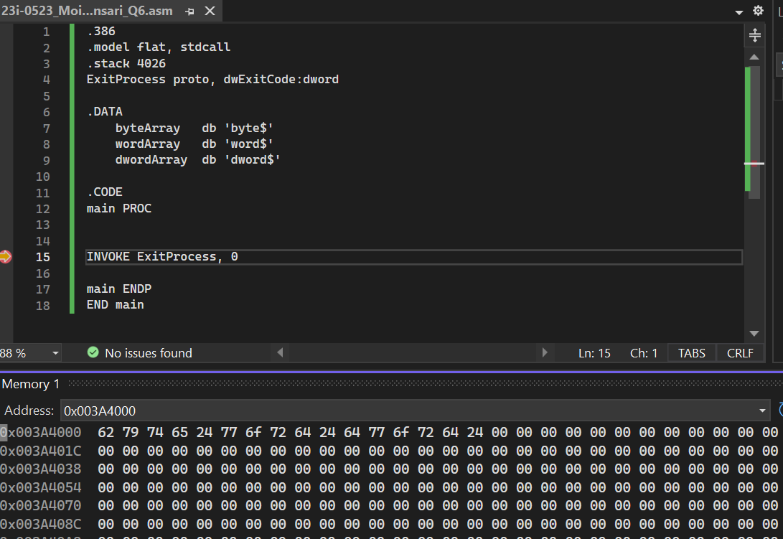
Q7: Calculate and Save Array Length
- Objective: Compute the length of an array (number of elements) and store this value.
- Steps:
  - Calculate the length of the byteArray (e.g., 5 elements) and store this in a variable, e.g., arrayLength db 5.
  - Repeat for wordArray and dwordArray.
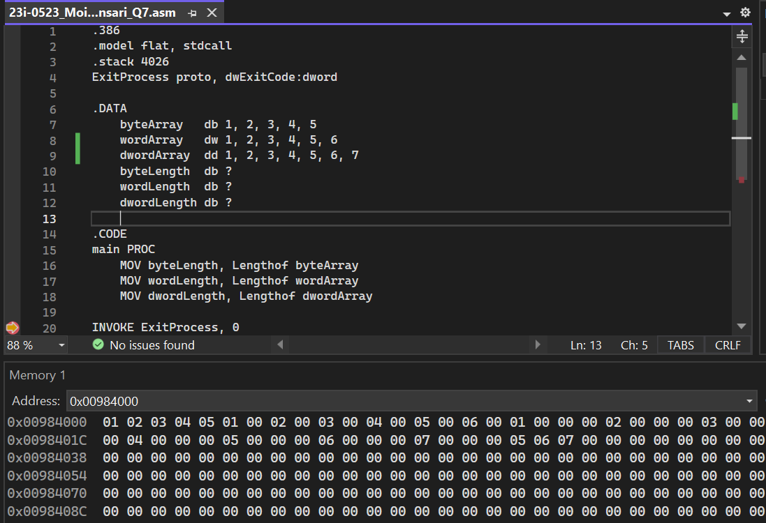
Q8: Calculate and Save Array Size
- Objective: Determine the total memory size occupied by the array and store this information.
- Steps:
  - For the byteArray, the size is simply the number of elements (e.g., 5 bytes).
  - For the wordArray, the size is the number of elements multiplied by 2 (e.g., 4 words * 2 bytes = 8 bytes).
  - For the dwordArray, the size is the number of elements multiplied by 4 (e.g., 3 dwords * 4 bytes = 12 bytes).
  - Store these sizes in variables, e.g., arraySize db 5 for bytes, arraySize dw 8 for words, etc.
